Naan Mudhalvan - Artificial Intelligence - Group1

Earthquake Prediction Model Using Python

Introduction:

- The problem is to develop an earthquake prediction model using a dataset. The objective is to explore and understand the key features of earthquake data, visualize the data on a world map for a global overview, split the data for training and testing, and build a neural network model to predict earthquake magnitudes based on the given features.

- It is well known that some areas are more vulnerable to natural disasters such as earthquakes. It's crucial to remember that while certain areas may have a history of frequent earthquakes, accurately predicting earthquakes based only on historical information, such as date and time, latitude, and longitude, is not the same as anticipating trends in more predictable phenomena. Earthquakes happen naturally, and their patterns are by nature complicated and frequently surprising.
Steps to follow:

- Import Libraries:
- Start by importing the necessary libraries.
import numpyas npimportpandasas pd
importmatplotlib.pyplotasplt

import osprint(os.listdir("../input"))
data=pd.read_csv("../input/database.csv")data.head()
data.columns
data=data[['Date','Time','Latitude','Longitude','Depth','Magnitude']]data.head()

.
import numpyas npimportpandasas pd
importmatplotlib.pyplotasplt

import osprint(os.listdir("../input"))
data=pd.read_csv("../input/database.csv")data.head()
data.columns
data=data[['Date','Time','Latitude','Longitude','Depth','Magnitude']]data.head()

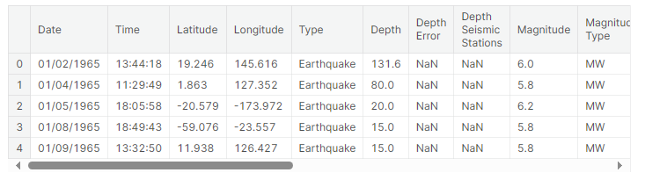data.columns

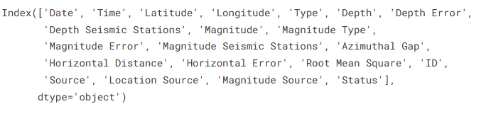

data=data[['Date','Time','Latitude','Longitude','Depth','Magnitude']]
data.head()

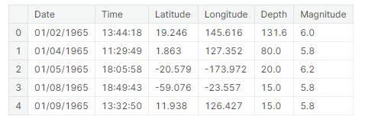
import datetime
import time
timestamp = []
for d, t in zip(data['Date'], data['Time']):try:
ts= datetime.datetime.strptime(d+' '+t, '%m/%d/%Y %H:%M:%S')timestamp.append(time.mktime(ts.timetuple()))timestamp.append('ValueError')
timeStamp= pd.Series(timestamp)
data['Timestamp']=timeStamp.values

2. DataPreparation:
- UsingPandas,youreadseismicdatafromaCSVfile.
- Youhandledatetimeparsingissuesandextractspecifiedcolumns(suchas"Timestamp,""Latitude,""Longitude,""Magnitude,"and"Depth").
- Rowswith"ValueError"inthe"Timestamp"columnareremove

final_data=data.drop(['Date','Time'],axis=1)
final_data=final_data[final_data.Timestamp!='ValueError']
final_data.head()

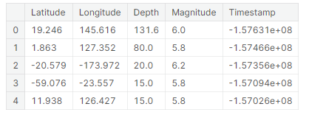
frommpl_toolkits.basemapimportBasemap

m=Basemap(projection='mill',llcrnrlat=-80,urcrnrlat=80,llcrnrlon=-180,urcrnrlon=180,lat_ts=20,resolution='c')

longitudes=data["Longitude"].tolist()
latitudes=data["Latitude"].tolist()
#m = Basemap(width=12000000,height=9000000,projection='lcc',
#resolution=None,lat_1=80.,lat_2=55,lat_0=80,lon_0=-107.)
x,y=m(longitudes,latitudes)

fig=plt.figure(figsize=(12,10))
plt.title("All affected areas")
m.plot(x,y,"o",markersize=2,color='blue')
m.drawcoastlines()
m.fillcontinents(color='coral',lake_color='aqua')
m.drawmapboundary()
m.drawcountries()
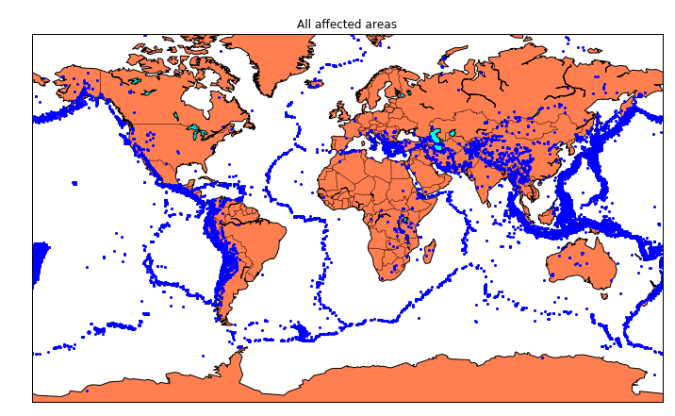
plt.show()

x,y= m(longitudes,latitudes)
fig=plt.figure(figsize=(12,10))plt.title("All affected areas")
m.plot(x, y, "o", markersize= 2, color = 'blue')m.drawcoastlines()m.fillcontinents(color='coral',lake_color='aqua')m.drawmapboundary()
m.drawcountries()plt.show()
timeStamp= pd.Series(timestamp)data['Timestamp']=timeStamp.value
final_data= data.drop(['Date', 'Time'], axis=1)
final_data= final_data[final_data.Timestamp!= 'ValueError']final_data.head

3. DataVisualization:
  - Tovisualizeearthquakelocationsonamap,constructaBasemap.
frommpl_toolkits.basemapimportBasemap

m=Basemap(projection='mill',llcrnrlat=-80,urcrnrlat=80,llcrnrlon=-180,urcrnrlon=180,lat_ts=20,resolution='c')

longitudes = data["Longitude"].tolist()latitudes=data["Latitude"].tolist()

x,y= m(longitudes,latitudes)
fig = plt.figure(figsize=(12,10))plt.title("All affected areas")
m.plot(x, y, "o", markersize= 2, color = 'blue')m.drawcoastlines()m.fillcontinents(color='coral',lake_color='aqua')m.drawmapboundary()
m.drawcountries()plt.show()

fromsklearn.ensembleimportRandomForestRegressor

reg=RandomForestRegressor(random_state=42)
reg.fit(X_train,y_train)
reg.predict(X_test)

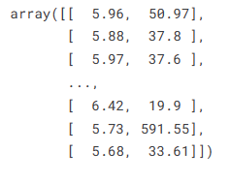

DataSplitting:

- Usingtrain_test_split,dividethedataintotrainingandtestingsets.
- YoutrainaRandomForestRegressorusingthetrainingsetofdata.
- Thescore()methodisusedtoassessthemodel.

fromkeras.modelsimportSequential
fromkeras.layersimportDense

defcreate_model(neurons,activation,optimizer,loss):
model=Sequential()
model.add(Dense(neurons,activation=activation,input_shape=(3,)))
model.add(Dense(neurons,activation=activation))
model.add(Dense(2,activation='softmax'))

model.compile(optimizer=optimizer,loss=loss,metrics=['accuracy'])

returnmodel

fromkeras.wrappers.scikit_learnimportKerasClassifier

model=KerasClassifier(build_fn=create_model,verbose=0)

# neurons = [16, 64, 128, 256]
neurons=[16]
# batch_size = [10, 20, 50, 100]
batch_size=[10]
epochs=[10]
# activation = ['relu', 'tanh', 'sigmoid', 'hard_sigmoid', 'linear', 'exponential']
activation=['sigmoid','relu']
# optimizer = ['SGD', 'RMSprop', 'Adagrad', 'Adadelta', 'Adam', 'Adamax', 'Nadam']
optimizer=['SGD','Adadelta']
loss=['squared_hinge']

param_grid=dict(neurons=neurons,batch_size=batch_size,epochs=epochs,activation=activation,optimizer=optimizer,loss=loss)

Hyper parameterTuning(GridSearch):
- GridSearchCVisusedtoadjustthehyperparametersoftheRandomForestRegressor.

grid=GridSearchCV(estimator=model,param_grid=param_grid,n_jobs=-1)
grid_result=grid.fit(X_train,y_train)

print("Best: %f using %s"%(grid_result.best_score_,grid_result.best_params_))
means=grid_result.cv_results_['mean_test_score']
stds=grid_result.cv_results_['std_test_score']
params=grid_result.cv_results_['params']
formean,stdev,paraminzip(means,stds,params):
print("%f (%f) with: %r"%(mean,stdev,param))

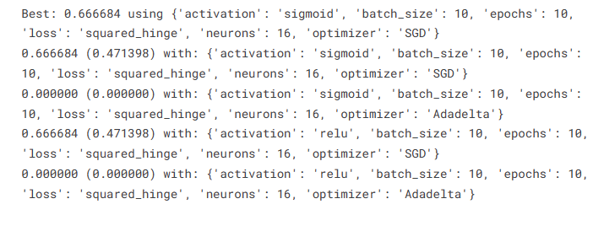
model=Sequential()
model.add(Dense(16,activation='relu',input_shape=(3,)))
model.add(Dense(16,activation='relu'))
model.add(Dense(2,activation='softmax'))

model.compile(optimizer='SGD',loss='squared_hinge',metrics=['accuracy'])

model.fit(X_train,y_train,batch_size=10,epochs=20,verbose=1,validation_data=(X_test,y_test))

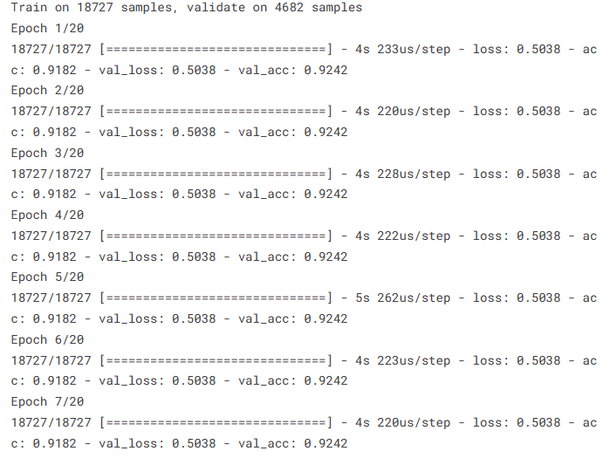
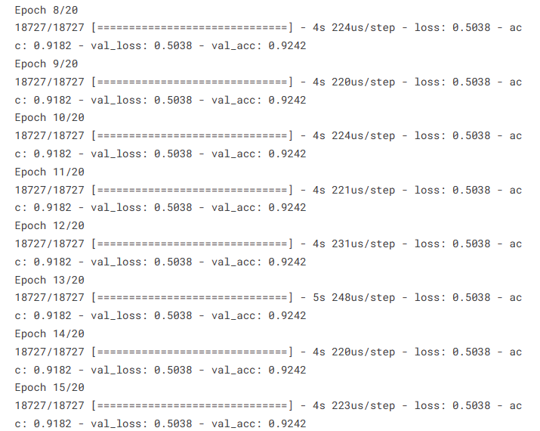
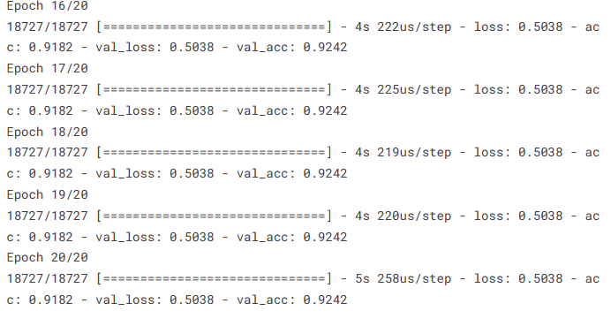

NeuralNetwork(Keras):
- YoubuildanearthquakepredictionKerasneuralnetworkmodel.
- Totunehyperparameters,youdefineaparametergrid.
- GridSearchCVisusedtoadjusttheneuralnetwork'shyperparameters.

model.add(Dense(neurons,activation=activation,input_shape=(3,)))model.add(Dense(neurons, activation=activation))model.add(Dense(2,activation='softmax'))
model.compile(optimizer=optimizer,loss=loss,metrics=['accuracy'])returnmodel
fromkeras.wrappers.scikit_learnimportKerasClassifier

model=KerasClassifier(build_fn=create_model,verbose=0)neurons=[16]
batch_size=[10]
epochs=[10]
activation=['sigmoid','relu']optimizer = ['SGD', 'Adadelta']loss=['squared_hinge']
param_grid=dict(neurons=neurons,batch_size=batch_size,epochs=epochs,activation=activation,optimizer=optimizer,loss=loss)
fromkeras.modelsimportSequentialfromkeras.layersimportDense

defcreate_model(neurons,activation,optimizer,loss):model=Sequential()

ModelEvaluation:
- Youusethetrainingdatatocreatethefinalneuralnetworkmodel.
- Usingthetestdata,youevaluatethemodel.
- Thetrainedneuralnetworkmodelissavedtoafilecalled"earthquake.h5"instep eight.
- ItappearsthatyouarenowaskingforchangestothecodeandasuitableCSVfile. Hereareafewideas:

DataQuality:
- Ensurethatyourseismicdataareofhighquality.Theperformanceofthemodeldependsonit.

FeatureEngineering:
Investigateanddevelopfreshcharacteristicsthatcouldraisepredictionprecision
grid=GridSearchCV(estimator=model,param_grid=param_grid,n_jobs=-1)grid_result=grid.fit(X_train,y_train)

print("Best:%fusing%s"%(grid_result.best_score_,grid_result.best_params_))means=grid_result.cv_results_['mean_test_score']
stds= grid_result.cv_results_['std_test_score']params=grid_result.cv_results_['params']
for mean, stdev, param in zip(means, stds, params):print("%f(%f)with:%r"%(mean, stdev,param))

HyperparameterTuning:
- To identify the ideal model configuration, experiment with varioushyperparametersforboththeneuralnetworkandtheRandomForestRegressor.

DataScaling:
- Scalingornormalizingyourinputfeaturesissomethingtothinkabout,especiallyifyou'reutilizingneuralnetworks.

Cross-Validation:
- Usecross-validationtoevaluatethestabilityofthemodelanddecreaseover fitting.

ModelEvaluationMetrics:
- Toevaluatetheperformanceofamodel,useappropriateevaluationmetricsfor regression tasks, such as Mean Absolute Error (MAE) or Mean SquaredError(MSE).
model = Sequential()
model.add(Dense(16, activation='relu', input_shape=(3,)))model.add(Dense(16,activation='relu'))model.add(Dense(2, activation='softmax'))

model.compile(optimizer='SGD', loss='squared_hinge', metrics=['accuracy'])
model.fit(X_train, y_train, batch_size=10, epochs=20, verbose=1, validation_data=(X_test, y_test))

DataSource:
- Check that the earthquake dataset you have access to is reputable and current.On websites like the USGS Earthquake Hazards Program,you can find earthquake datasets.
[test_loss,test_acc]=model.evaluate(X_test,y_test)
print("EvaluationresultonTestData:Loss={},accuracy={}".format(test_loss,test_acc))

Filedirectories:

- Ensure that the file Directories you use to load data and save models are precise and easy to retrieve.

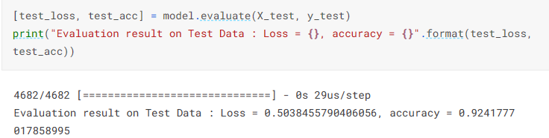

model.save('earthquake.h5')

Conclusion:

In order to properly build a CSV file for earthquake data, make sure your dataset has necessary columns like "Date", "Time", "Latitude", "Longitude", "Magnitude" and "Depth." You can get reliable sources for earthquake data, such as the USGS Earthquake Hazards Program or others, from these repositories.
When you obtain the data, verify that it is in the right format and make any necessary changes to your code to properly process and use this important information.
Conclude the document by summarizing the project’s achievements, the effectiveness of the earthquake prediction model, and its potential real-world applications.
This design thinking document provides a structured roadmap for developing an earthquake prediction model, ensuring that each crucial step is addressed systematically. It promotes a data-driven approach and continuous improvement for achieving accurate earthquake magnitude predictions.

